Morphological Gradient Using OpenCV
Experiment No: 33
Aim
To perform the morphological gradient operation on an image using OpenCV in Python.
Tools Required
- Python 3.x
- OpenCV (cv2)
- NumPy
- VS Code / PyCharm / Jupyter Notebook
- Input image (image.jpg)
Theory
The Morphological Gradient is obtained by subtracting the eroded image from the dilated image.
It is mainly used for detecting and highlighting the boundaries or edges of objects in an image.
OpenCV provides the cv2.MORPH_GRADIENT operation to perform this directly.

Procedure
- Install OpenCV and NumPy:
Bash
pip install opencv-python numpy
- Read the input image using OpenCV.
- Convert the image to grayscale.
- Create a structuring element (kernel).
- Apply the morphological gradient using cv2.morphologyEx().
- Display the original and gradient images.
- Save the resulting image
Code
import cv2
import numpy as np

# Read the image
image = cv2.imread("image.jpg")

# Check if image is loaded
if image is None:
print("Error: Image not found!")
exit()

# Convert image to grayscale
gray = cv2.cvtColor(image, cv2.COLOR_BGR2GRAY)

# Create a structuring element
kernel = np.ones((5, 5), np.uint8)

# Perform morphological gradient
gradient = cv2.morphologyEx(
gray,
cv2.MORPH_GRADIENT,
kernel
)

# Display original image
cv2.imshow("Original Image", gray)

# Display morphological gradient
cv2.imshow("Morphological Gradient", gradient)

# Save the output
cv2.imwrite("morphological_gradient.jpg", gradient)

cv2.waitKey(0)
cv2.destroyAllWindows()
Output
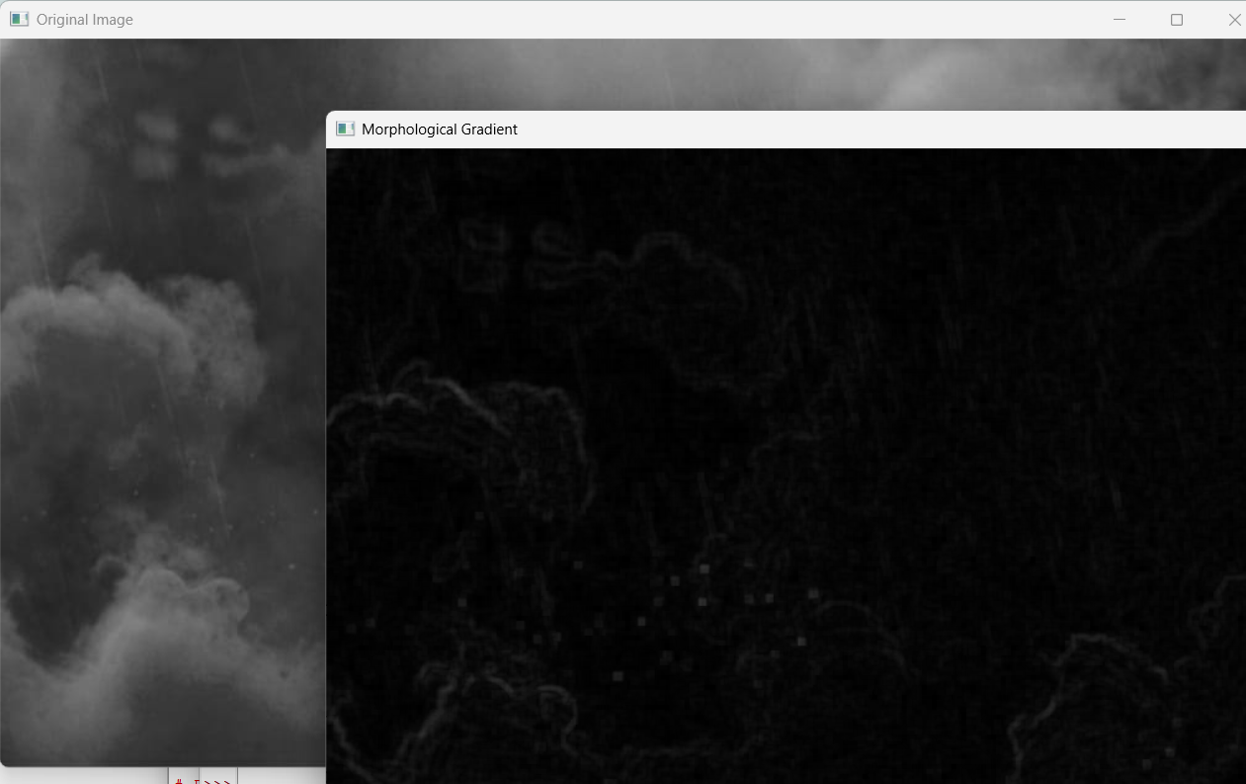
Result
The morphological gradient operation was successfully performed using OpenCV. The difference between the dilated and eroded images was used to highlight the boundaries of objects in the image.

